**Dennis Tikhomirov. DevOps Spring’19.**

**Task 3. Hyper-V**

1. Using the GUI, create the following VM without a network connection:

• Windows 7 (comp1)

• Windows Server 2016 (server)

• Ubuntu 18.04 (comp2)

1. Using the PowerShell, create the following VM without a network connection:

• Windows 7 (comp3)

• Windows 10 (comp4)

• Ubuntu 19.04 (comp5)

Screenshot #1. Hyper-V manager, deployed VMs

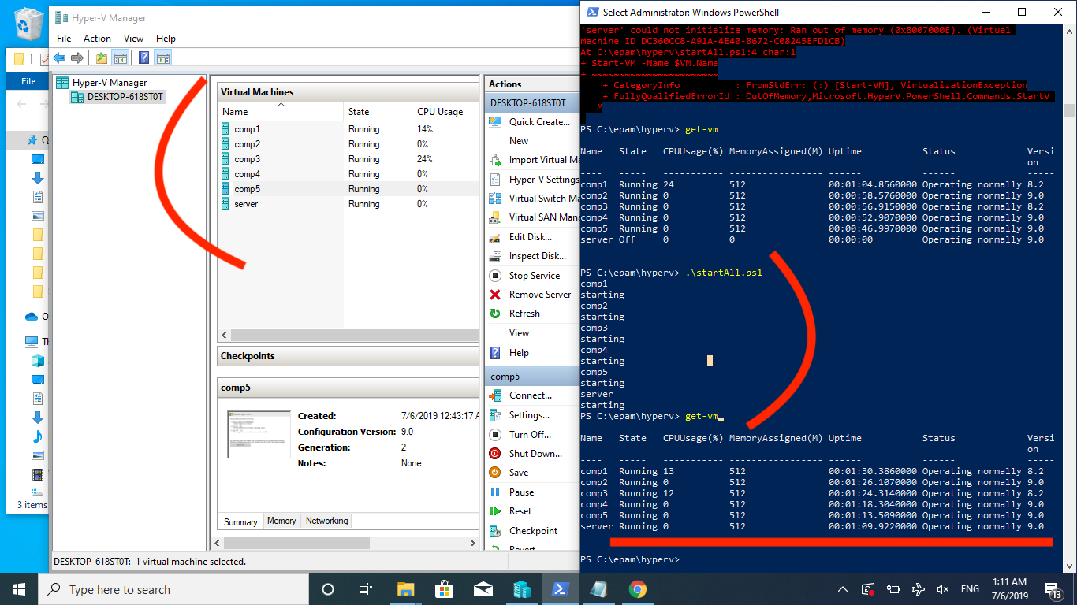

I have created bunch of scripts for managing VMs on Hyper-V host.

#1. List of VMs <https://github.com/dennis00010011b/epam-devops-training/blob/master/Task3HyperV/VMs.xml>

<?xml version="1.0"?>  
<VMs>  
 <VM>  
 <Name>comp1</Name>  
 <SourcePath>C:\ISOs\IE11.Win7.HyperV\Virtual Machines\106A06B0-0DE9-4997-A87C-3760FFBEC837.vmcx</SourcePath>  
 <IsImport>true</IsImport>  
 <Memory>536870912</Memory>  
 <VHDPath>./</VHDPath>  
 <OS>Wni7</OS>  
 </VM>  
  
 <VM>  
 <Name>comp2</Name>  
 <SourcePath>C:\ISOs\ubuntu-18.04.2-desktop-amd64.iso</SourcePath>  
 <Memory>536870912</Memory>  
 <VHDPath>./</VHDPath>  
 <OS>Ubuntu18.04</OS>  
 </VM>  
  
 <VM>  
 <Name>comp3</Name>  
 <SourcePath>C:\ISOs\IE11.Win7.HyperV\Virtual Machines\106A06B0-0DE9-4997-A87C-3760FFBEC837.vmcx</SourcePath>  
 <IsImport>true</IsImport>  
 <Memory>536870912</Memory>  
 <VHDPath>./</VHDPath>  
 <OS>Wni7</OS>  
 </VM>  
  
 <VM>  
 <Name>comp4</Name>  
 <SourcePath>C:\ISOs\Win10_1809Oct_v2_English_x64.iso</SourcePath>  
 <Memory>536870912</Memory>  
 <VHDPath>./</VHDPath>  
 <OS>Wni10</OS>  
 </VM>  
  
 <VM>  
 <Name>comp5</Name>  
 <SourcePath>C:\ISOs\ubuntu-19.04-desktop-amd64.iso</SourcePath>  
 <Memory>536870912</Memory>  
 <VHDPath>./</VHDPath>  
 <OS>Ubuntu19.04</OS>  
 </VM>  
  
 <VM>  
 <Name>server</Name>  
 <SourcePath>C:\ISOs\Windows_Server_2016_Datacenter_EVAL_en-us_14393_refresh.ISO</SourcePath>  
 <Memory>1036870912</Memory>  
 <VHDPath>./</VHDPath>  
 <OS>Ubuntu19.04</OS>  
 </VM>  
</VMs>

#2. PS script for creating VMs <https://github.com/dennis00010011b/epam-devops-training/blob/master/Task3HyperV/createVM.ps1>

$VMName = $args[0]  
$ISO = $args[1]  
$Memory = $args[2]  
$VHDPath = $args[3]  
 $VM = @{  
 Name = $VMName  
 MemoryStartupBytes = $Memory  
 Generation = 2  
 NewVHDPath = "$VHDPath$VMName.vhdx"  
 NewVHDSizeBytes = 53687091200  
   
 }  
 echo Creating $VMName $ISO $Memory $VHDPath  
 New-VM @VM  
  
 Add-VMDvdDrive -VMName $VMName -Path $ISO  
  
 $firmw = Get-VMFirmvare $VMName  
 Set-VMFirmvare -VMName $VMName -BootOrder $firmw.BootOrder[2]

#3. PS script for deploying VMs <https://github.com/dennis00010011b/epam-devops-training/blob/master/Task3HyperV/deploy.ps1>

[xml]$XmlDoc = Get-Content VMs.xml  
  
foreach ($VM in $XmlDoc.VMs.VM) {  
 if ($VM.isImport) {  
 Import-VM -Path $VM.SourcePath -VhdDestinationPath $VM.VHDPath -Copy -GenerateNewId  
 }  
 else{  
 .\createVM.ps1 $VM.Name $VM.SourcePath $VM.Memory $VM.VHDPath  
 }  
}

#4. PS script for removing VMs <https://github.com/dennis00010011b/epam-devops-training/blob/master/Task3HyperV/removeAll.ps1>

[xml]$XmlDoc = Get-Content VMs.xml  
foreach ($VM in $XmlDoc.VMs.VM) {  
 remove-vm $VM.Name -force  
 if (-Not($VM.isImport)) {  
 remove-item "$(Join-Path $VM.VHDPath $VM.Name).vhdx"  
 }  
}

1. Using the PowerShell for computers “comp1”, “comp4”, “comp5” configure NAT and Internet access

# Create internal vSwitch  
new-vmswitch -SwitchName "IntSwitch" -SwitchType Internal  
  
# Create IPGateway  
new-netipaddresstIPAddress 192.168.2.1 -PrefixLength 24 -InterfaceAlias "vEthernet (IntSwitch)"  
  
#Create NAT network  
new-netnat -name "NAT55" -InternalIPInterfaceAddressPrefix 192.168.2.0/24  
  
#Connect VMs to vSwitch  
connect-vmnetworkadapter -VMName comp1,comp4,comp5 -SwitchName IntSwitch  
  
# set manually IPAdress on each VM  
# for comp#4  
new-netipaddress 192.168.2.2 -InterfaceAlias "Ethernet"  
  
# for comp#1 (Windows7)  
$adapter = Get-WmiObject win32_networkadapterconfiguration -filter “ipenabled = ‘true'”  
$adapter.EnableStatic(“192.168.2.4”, “255.255.255.0”)  
  
#for comp#5 (Ubuntu 19.04)  
sudo ifconfig eth0 add 192.168.2.10 netmask 255.255.255.0

1. Check your settings from the command line (terminal)

Screenshot #2. Connection between comp1,comp2,host via internal vSwitch

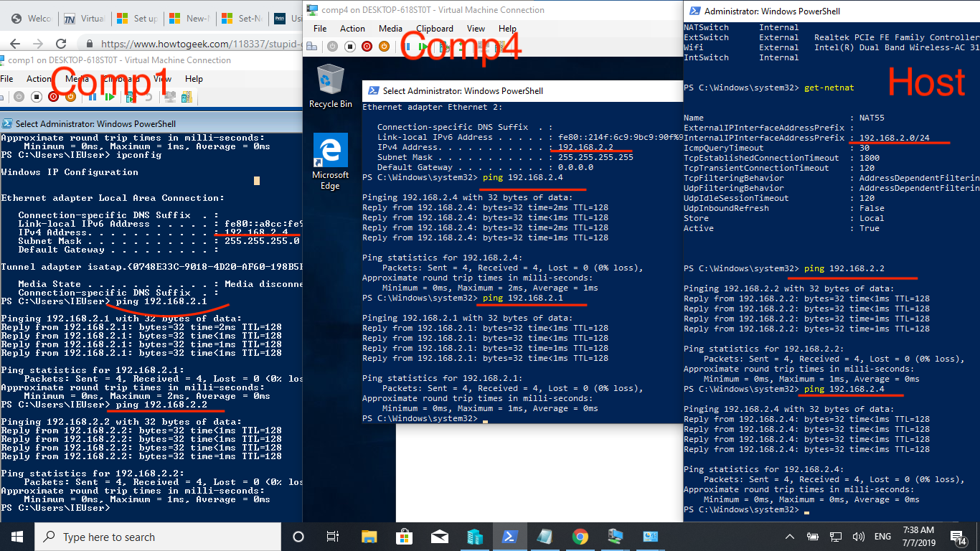

Screenshot #3. Connection between comp5 ,host via internal vSwitch

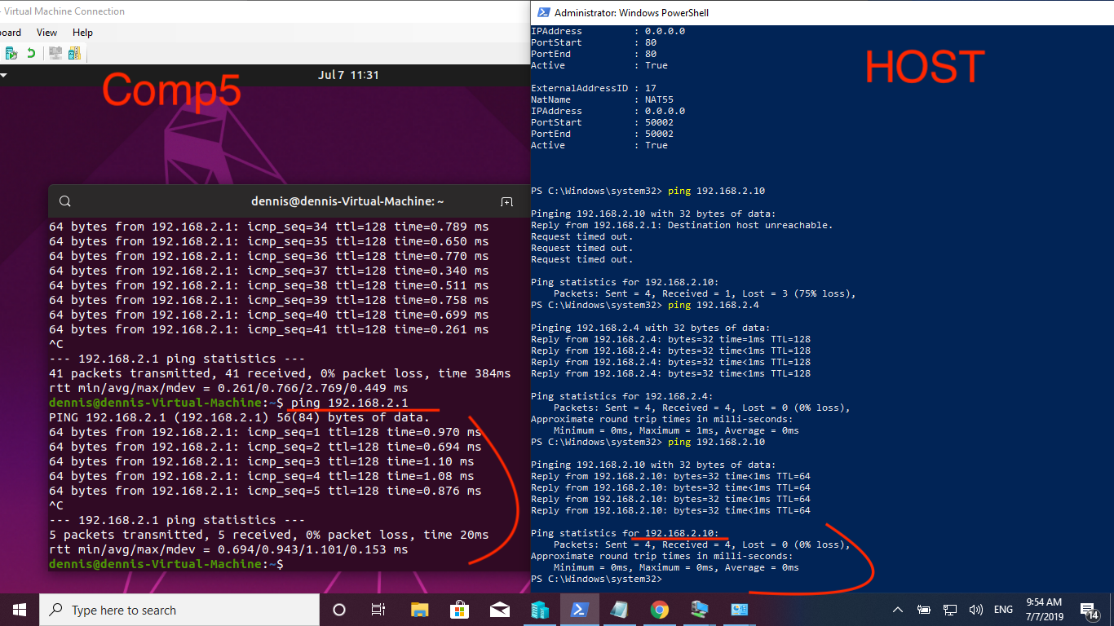

1. Using the PowerShell, add the remaining VM into a network by creating a new vSwitch

New internal vSwitch is created, 192.168.2.101

# One more vSwitch   
new-vmswitch -SwitchName "IntSwitch2" -SwitchType Internal  
new-netipaddress -IPaddress 192.168.2.101 -PrefixLength 24 -InterfaceAlias "vEthernet (IntSwitch2)"  
сonnect-vmnetworkadapter -VMName comp2,comp3,server -SwitchName IntSwitch2  
  
# set manually IPAdress on each VM  
# for 'server' (Windows Server 2016)  
new-netipaddress 192.168.2.102 -PrefixLength 24 -InterfaceAlias "Ethernet"  
  
#for comp#2 (Ubuntu 18.04)  
sudo ifconfig eth0 add 192.168.2.104 netmask 255.255.255.0  
  
# for comp#3 (Windows7)  
$adapter = Get-WmiObject win32_networkadapterconfiguration -filter “ipenabled = ‘true'”  
$adapter.EnableStatic(“192.168.2.103”, “255.255.255.0”)

Screenshot #4. Connection between comp3,server, host via internal vSwitch

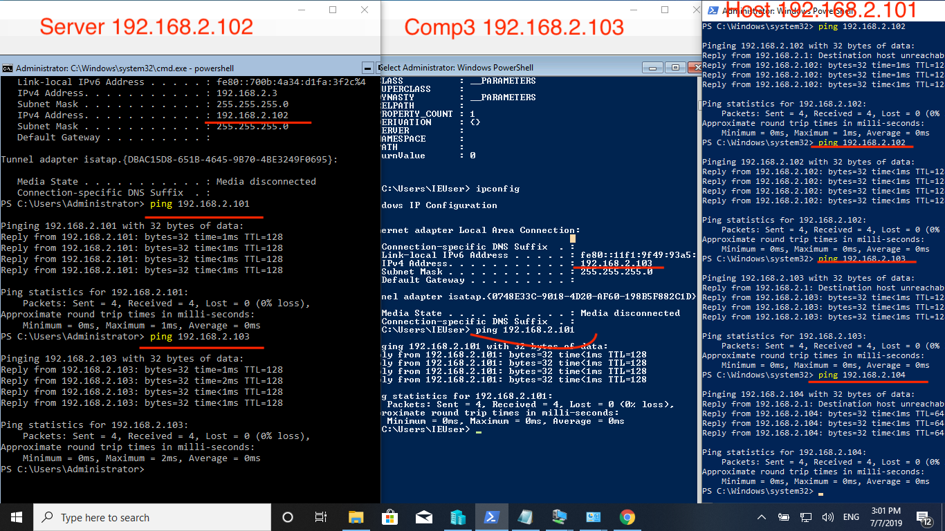

1. Configure DHCP on “server”

Screenshot #5. DHCP server configuration

# Install DHCP

Import-Module ServerManager

Add-WindowsFeature -name DHCP -IncludeManagmentTools

#Add Scope

Add-DHCPServerV4Scope -Name Pool1 -StartRange 192.168.2.1 -EndRange 192.168.2.200 -SubnetMask 255.255.255.0 -State Active

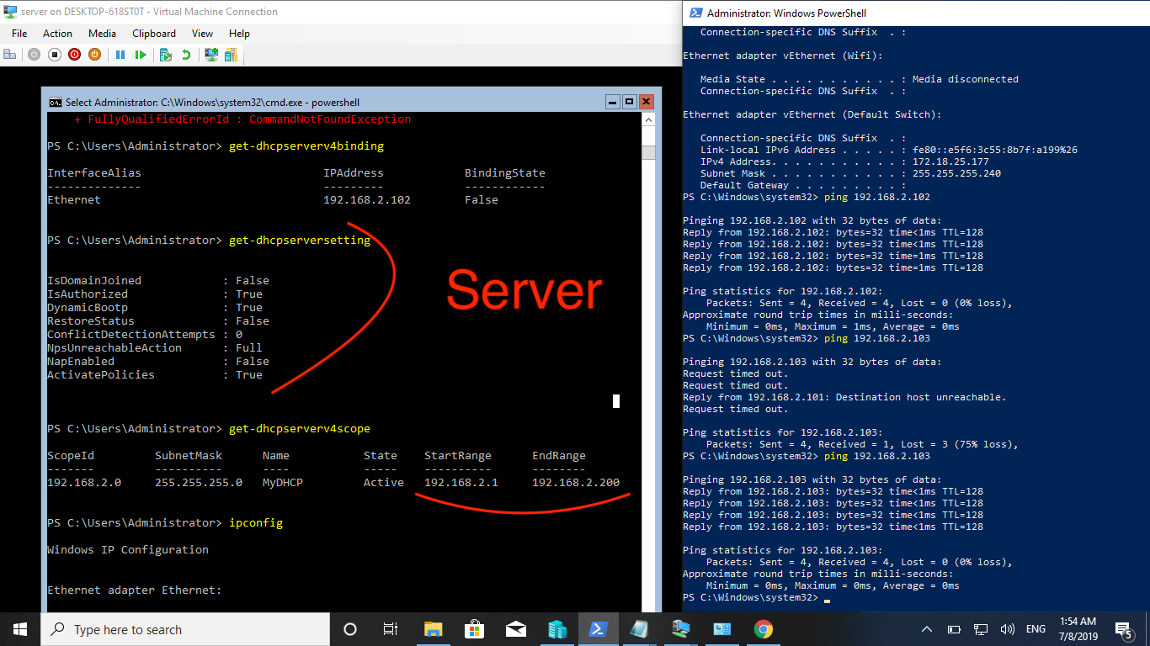

1. Configure the LAN and Internet access
2. Check your settings from the command line (terminal)

See screenshots above

9. Configure remote desktop connection to each VM

#Screenshot 6. Remote desktop connection to comp1 (Windows 7)

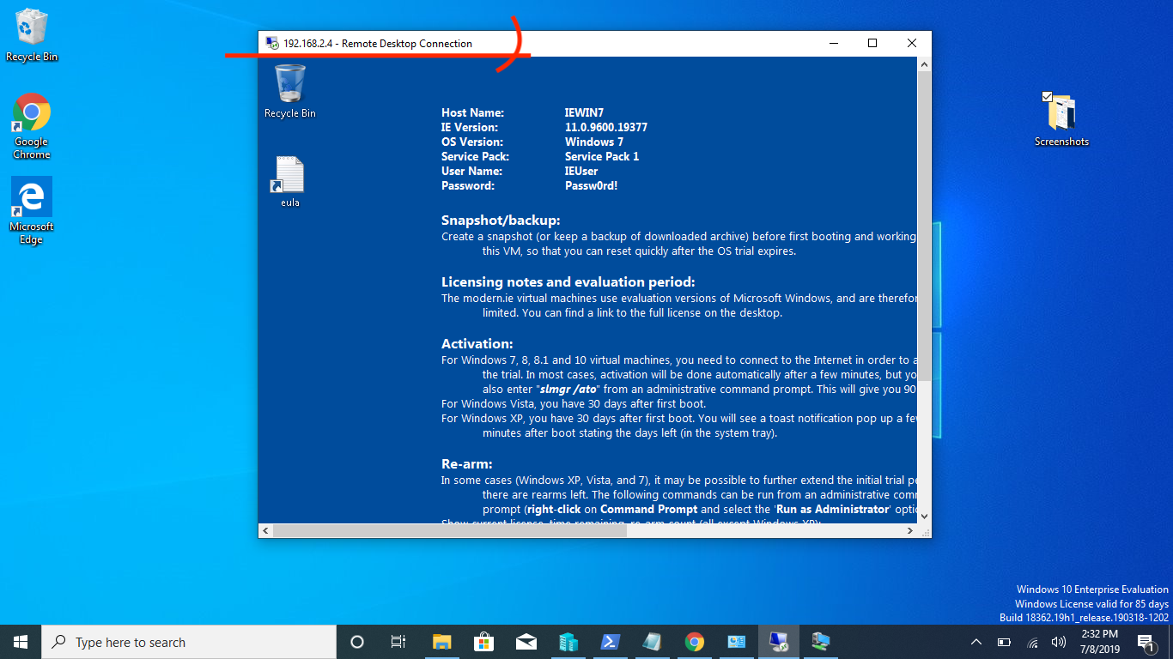

#Screenshot 7. File transfer via RDP between shared host’s drive C and guest comp 1 (Windows 7)

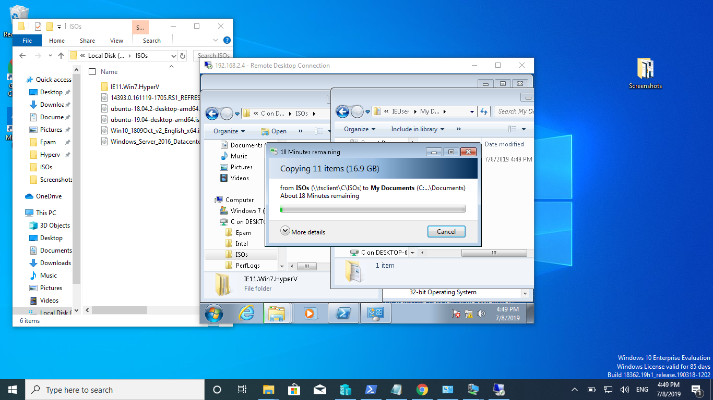

#Screenshot 8. RDP is not supported for Windows10 Home(comp4)

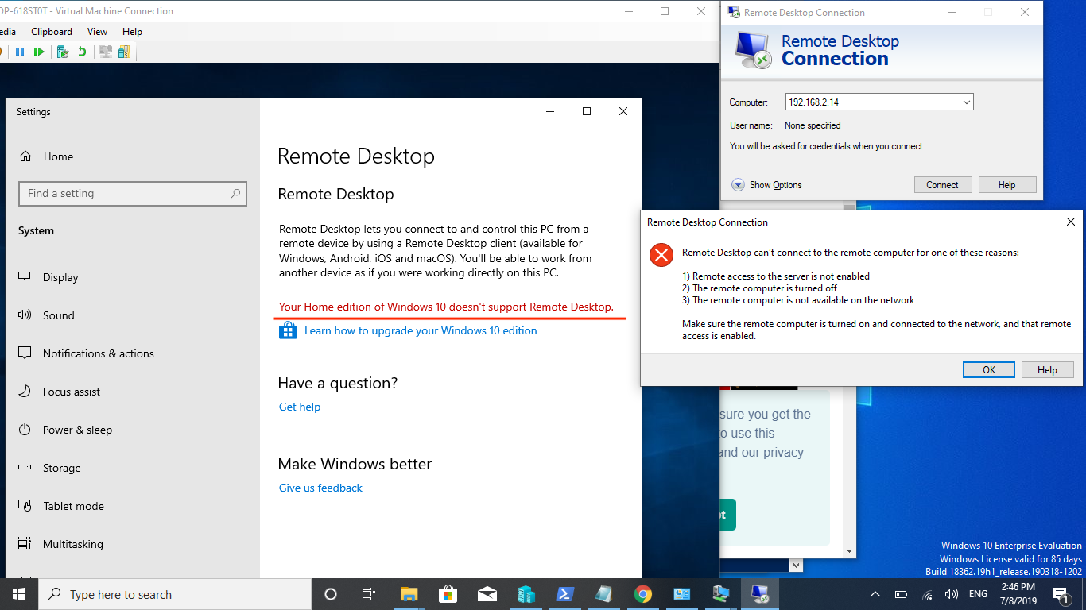

10. On the VM "server" install Hyper-V, which install 2 VM with Windows 7 ("comp6" and "comp7”)

I have no enough recourses for that

11. Demonstrate file transfer and editing from Host to Guest and back

See screenshot #7 above

12. Create a report with screenshots and attach script files that demonstrate the solution of tasks

See report above